 | EBRD press release  EBRD engages with Georgia to improve nursing & midwifery skills  Bank in partnership with the Ministry of Internally Displaced Persons from the Occupied Territories, Labour Health, and Social Affairs creates opportunities for skilled labour in healthcare. |  |  | 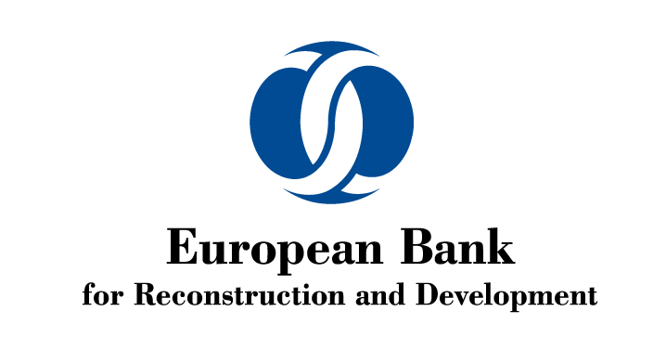
FOR IMMEDIATE RELEASE
 |  | www.ebrd.com/news | 
Date: 15/05/2020  Contact: Loretta Martikian  Tel: +995577221120  Email: martikianl@ebrd.com  Twitter: @LoraMartikian |  |  | Tags: #EBRD, #Georgia, #healthcare, #nurses, #nursing, #inclusion

- EBRD is engaged in improving nursing and midwifery skills in Georgia.
- MoU with MoIDPsLHSA of Georgia signed on International Nurses Day (12 May) on skills development.
- Funding is part of EBRD’s policy engagement initiative through Technical Assistance
The Ministry of Internally Displaced Persons from the Occupied Territories, Labour, Health and Social Affairs of Georgia (MoIDPsLHSA) and the European Bank for Reconstruction and Development (EBRD) are launching a new initiative this week to improve nursing and midwifery occupations through professional licencing, related skill standards and implementation support. The two organisations signed a Memorandum of Understanding (MoU) on Tuesday 12 May in celebration of International Nurses Day for a joint collaboration over the coming two years.
The partners agreed to co-operate more closely in realising three core objectives:
  - Establishing core governance principles and institutional standards for Georgia’s forthcoming professional licencing / certification scheme for nurses (including midwives), building on global best practice models and customising to the national context;
  - Establishing detailed knowledge criteria, exam standards and a test-bank aligned to the new professional licencing / certification scheme; and
  - Designing and piloting a short-term continuous learning programme to help further strengthen nurses’ capacities and existing knowledge in accordance with the new licencing / certification requirements.
The new initiative is closely aligned with the Government’s key healthcare priorities outlined in Vision for Developing the Healthcare System (201-2030) of Parlaiament of Georgia and the Ministry’s Strategy for the Development of Nursing (2019-2025). It also comes at a critical time in strengthening healthcare standards to fortify Georgia’s broader response under the ongoing crisis of COVID-19 pandemic.
EBRD is a leading institutional investor in Georgia. Since the start of its operations in the country, the Bank has invested over €3.8 billion in 250 projects in the financial, corporate, infrastructure and energy sectors, of which 87 per cent were in the private sector.
The new initiative builds upon ongoing collaborations and is aligned with EBRD’s goals around economic inclusion in Georgia. Over the past two years, EBRD has provided support to deliver key achievements in promoting more effective and sustainable nursing across the country. The Bank has been engaged with local partners in (i) advancing skills standards for degree-level nursing and midwifery programmes; (ii) developing Georgian-language nursing textbooks; and (iii) helping to improve outreach to male nurses to tackle the gender gap and further expand the potential labour pool.
This initiative goes beyond local partnerships, as the World Health Organization (WHO) designated 2020 as an “International Year of Nurses and Midwifes”. Global commitment to strengthen nursing and midwifery occupations presents an opportunity to gain momentum and reaffirm Georgia’s position towards achieving sustainable economic growth.
The new programme is generously funded by the Government of Japan through the Japan-EBRD Cooperation Fund (JECF) that promotes economic inclusion through technical assistance.

Once again, this memorandum illustrates continuous efforts of both parties to implement structural and sectoral economic reforms and ensure greater socio-economic prosperity of Georgia.

